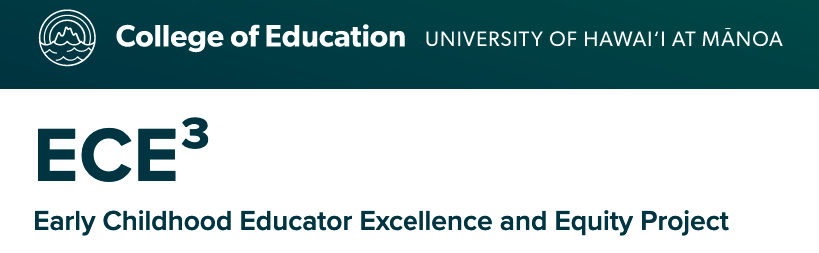

The ECE³ Task Force consists of the following members:
- Krystal Jo - O‘ahu
- Malia Pimentel - O‘ahu
- Dena Akiu - O‘ahu
- Diane Mokuhaliʻi - O‘ahu
- Alexandria Domingo - Maui
- Jen Townsend - O‘ahu
- Paula Yanagi - Hawai’i Island
- Donja Morton - O‘ahu
- Johnnetta Jordan-Piper - O‘ahu
- Traci Garma - O‘ahu
- Sheri Funasaki - O‘ahu
- Gary Emelle - O‘ahu
- Colleen Fratinardo - Hawai’i Island
- Mandie Gibson - Kaua`i

